**LAB REPORT NO 9**



Submitted by:  **Muhammad Ali**

Registration No: - **19PWCSE1801**

Class Section: A

“On my honor, as student of University of Engineering and Technology, I have neither given nor received unauthorized assistance on this academic work.”

Submitted to:

**Engr. Durr-e-Nayab**

Data:(11,07,2021)

Department of Computer Systems Engineering

University of Engineering and Technology, Peshawar

**Task no 1: -**

clc

clear all

close all

t = 0:19;

xt = cos(2*pi*t/2);

stem(t, xt); % plot signal

xlabel('time, t');

ylabel('Amplitude, A');

title('descret Time Cosine');

abs_xt_2 = abs(xt).^2; % take absolute square of signal

T = 20;

pxt = sum(abs_xt_2)/T % power of given signal

**Output: -**

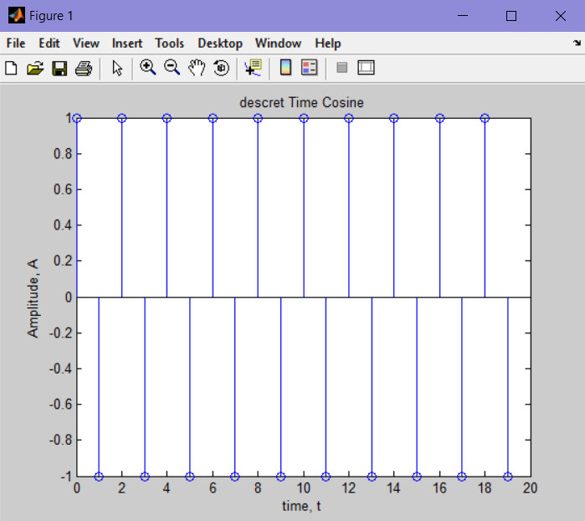

pxt =

1

>>

**Task no 2: -**

clc

clear all

close all

t=0:0.0001:10;

ff=0.15;

A = (4/pi);

s=sin(2*pi*ff*t);

y=A*s;

% COMPLEX AMPLITUDE = (4/(j*pi*k))

for k = 1:2:34

fh=k*ff;

x = (4/(k*pi))*sin(2*pi*fh*t);

y=y+x;

end

plot(t,y,'linewidth',1.5);

title('A square wave with harmonics 1st, 3rd, 5th, upto 17');

xlabel('Time');

ylabel('Amplitude')

figure;

for k = 1:2:54

f=k*ff;

x = (4/(k*pi))*sin(2*pi*f*t);

y=y+x;

end

plot(t,y,'linewidth',1.5);

title('A square wave with harmonics 1st, 3rd, 5th, upto 27');

xlabel('Time');

ylabel('Amplitude')

**Output: -**

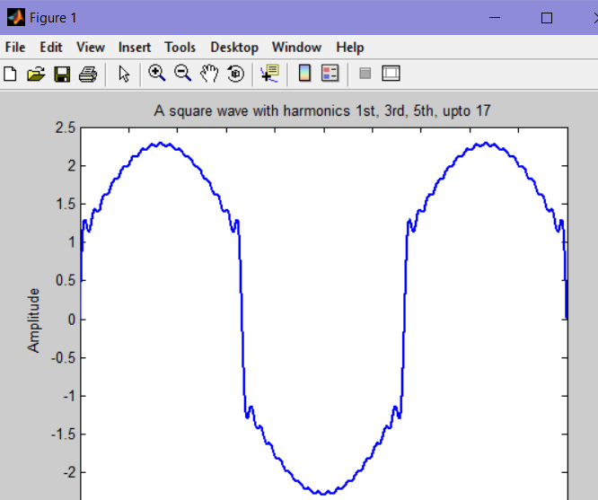

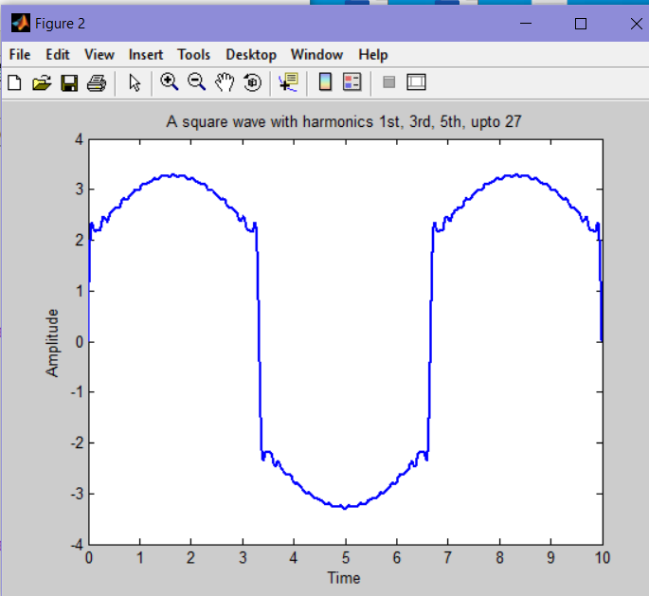

**Task no 3: -**

clc

clear all

close all

t = 0:0.1:4;

n=1;

s = sin(2*pi*n*t); % generate signal

for n = 3:2:9

nt=n*t;

x=(sin(2*pi*nt))/n;

x=x+s;

end

plot(t,x); % plot signal

xlabel('time, t');

ylabel('Amplitude, A');

title('s(t)');

**Output: -**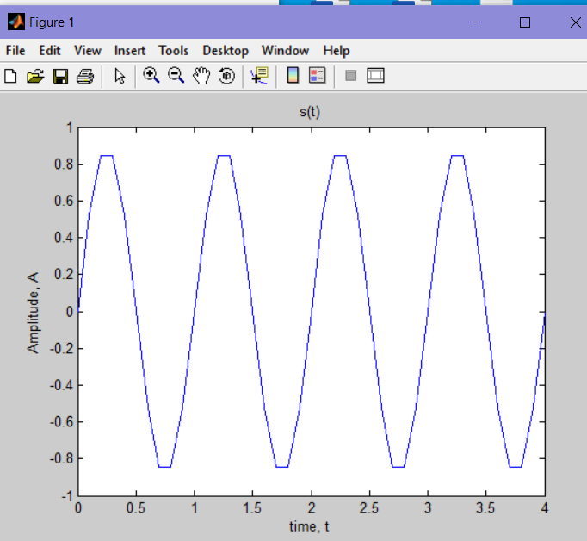

**Task no 4: -**

clc;

clear all;

close all

t=0:0.001:7;

x=(-8/(pi*pi))*exp(i*(2*pi*0.5*t));

for N=1:2:11

y=(-8/(9*pi*pi))*exp(i*(2*pi*0.5*N*t));

s=x+y;

end;

plot(t,real(s),'linewidth',1);

title('Triangular Wave with N=11');

ylabel('Amplitude');

xlabel('Time');

**Output: -**

